**EXPERIMENT-10:**

10)Install and explore Selenium for automated testing

**STEPS**

* Open chrome ,and click on settings,and click on visit chrome web store
* Click on extentions
* 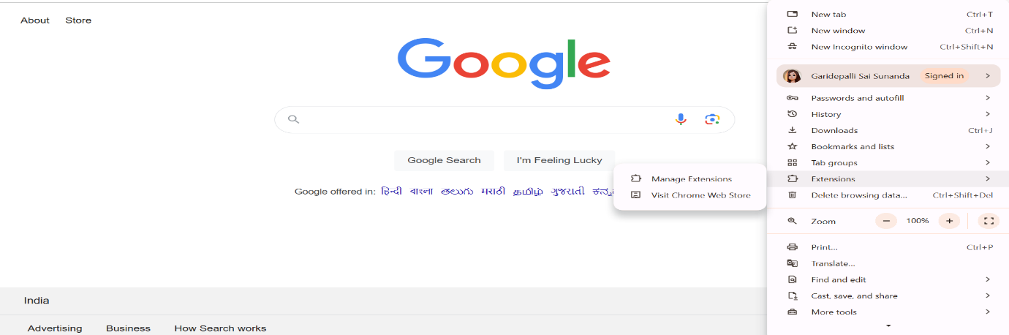Search for **SELENIUM IDE**

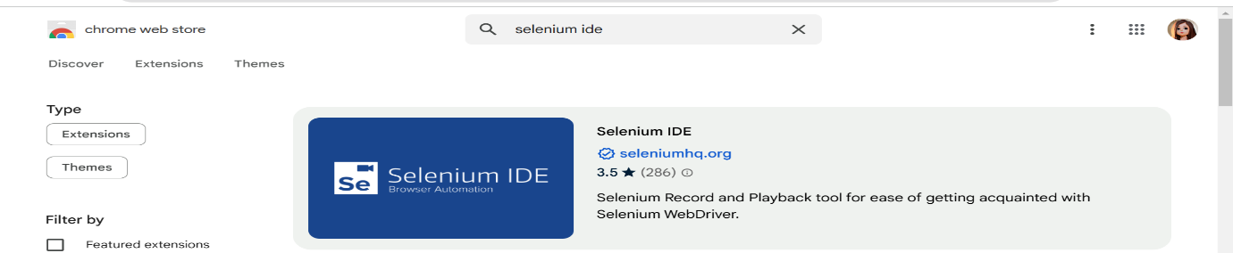

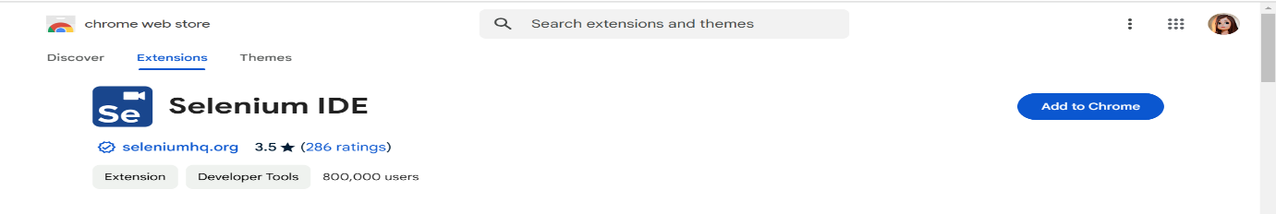

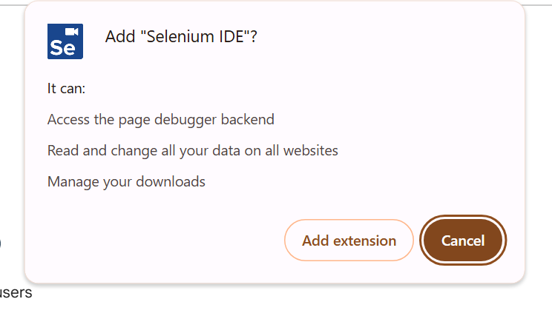

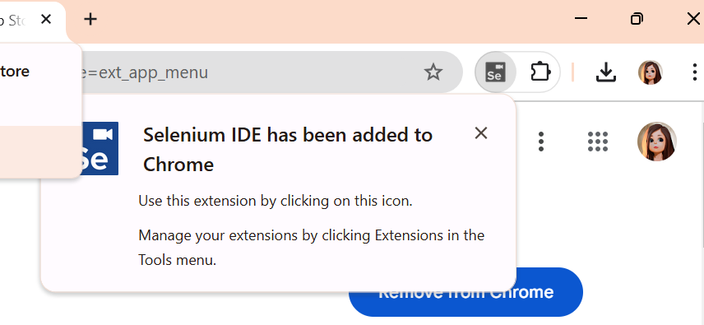

* 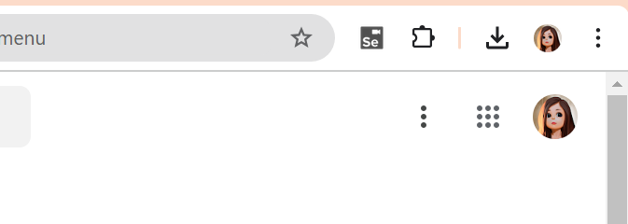Now we can see the selenium extention on top right corner
* By clicking on that we can see the below page and create a project

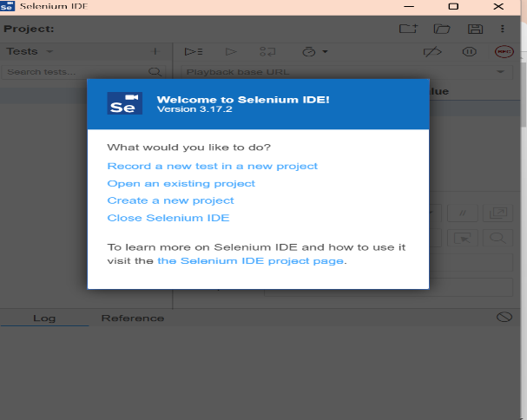

* 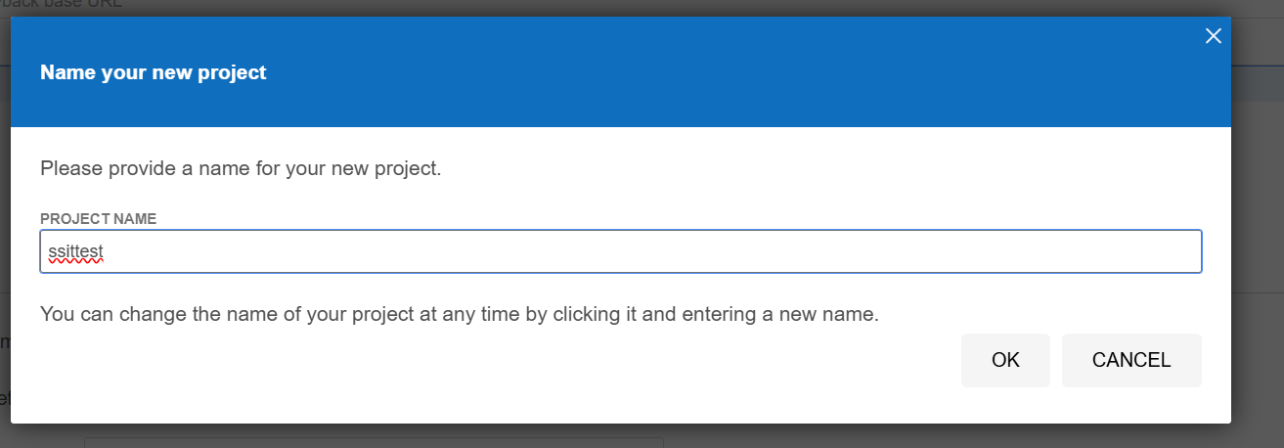Give the project name
* 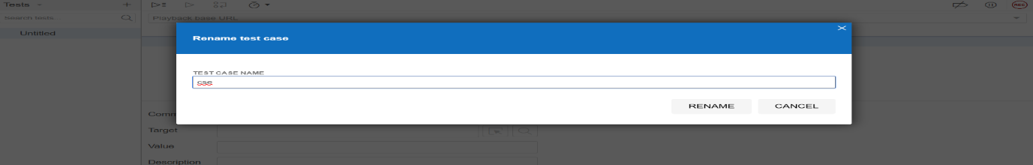Rename the project name as **website-test-ssit** and click on **REC**

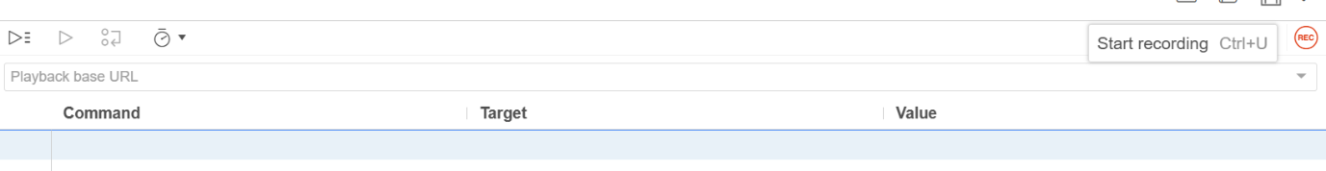

* 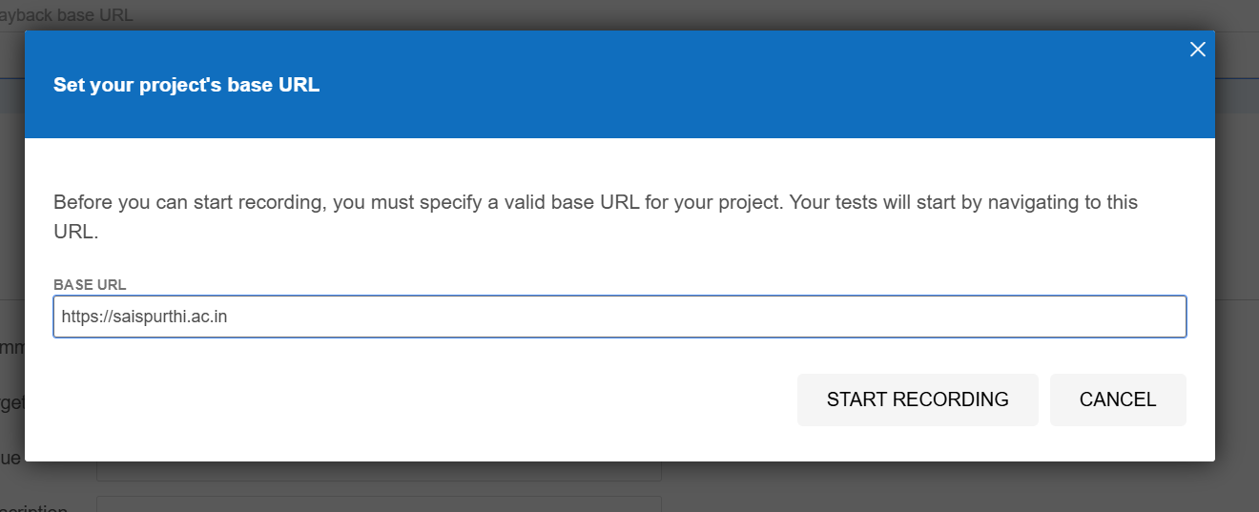And give the URL odf any website i.e [**http://saispurthi.ac.in**](http://saispurthi.ac.in/) and click on start recording. And it will records what we are doing in that website

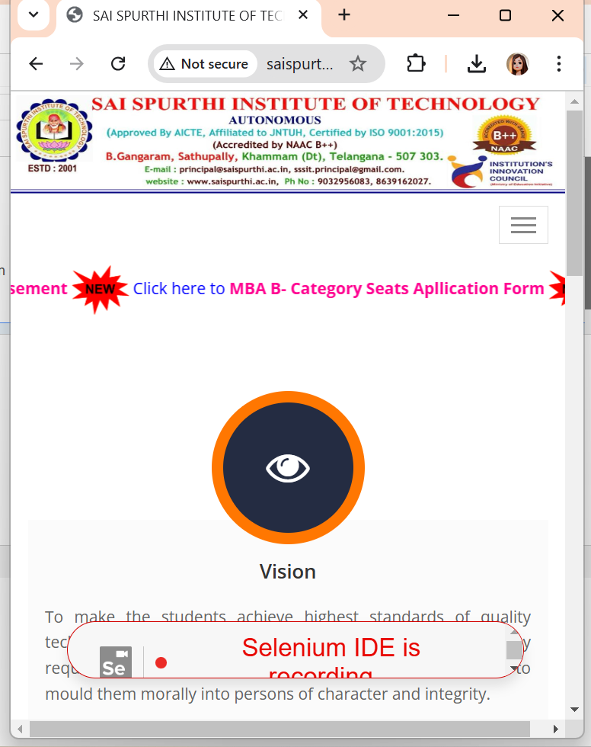

* After completing stop the recording click on run to view our recording

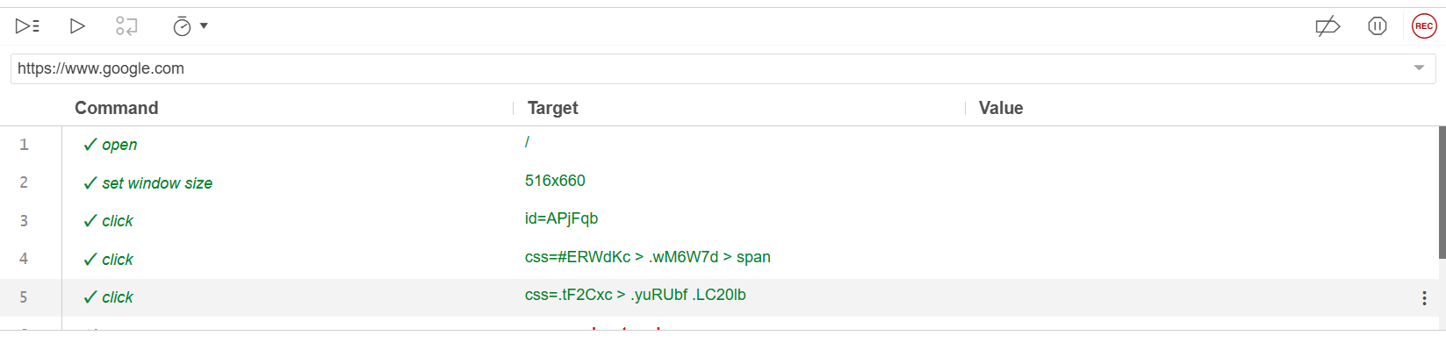

* Creating a maven project in ECLIPSE

### Steps

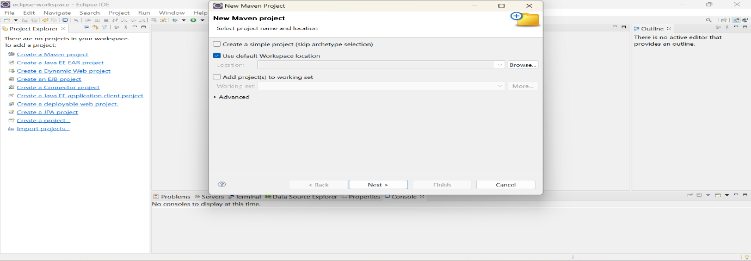1.click on create a maven project,and click on next

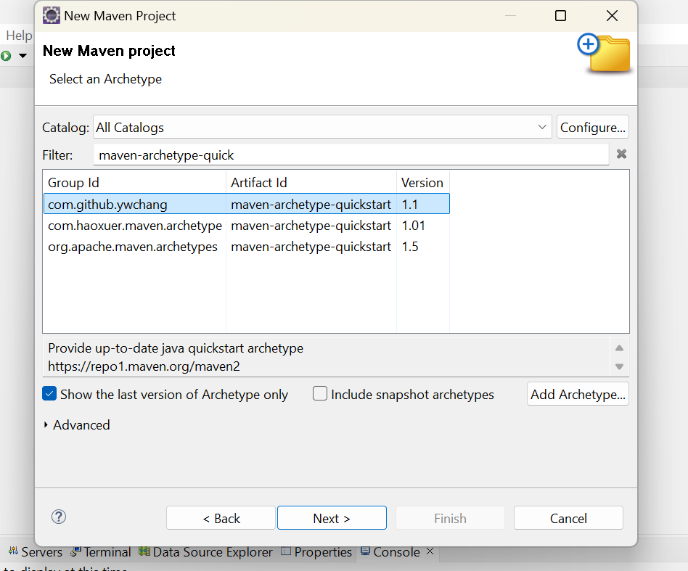2.select the artifact and click on next

3. give the **group id** and **artifact id** and click on finish

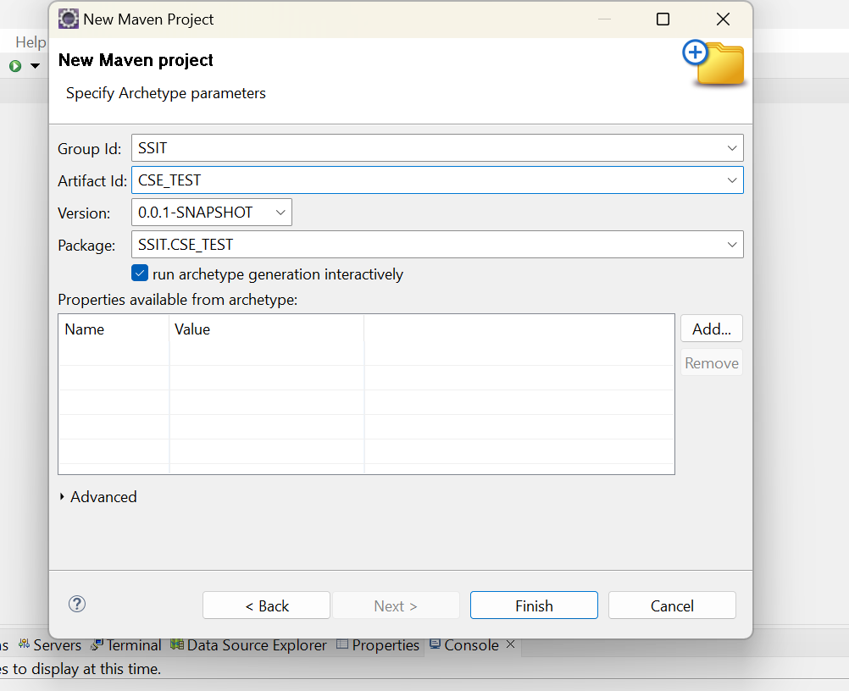

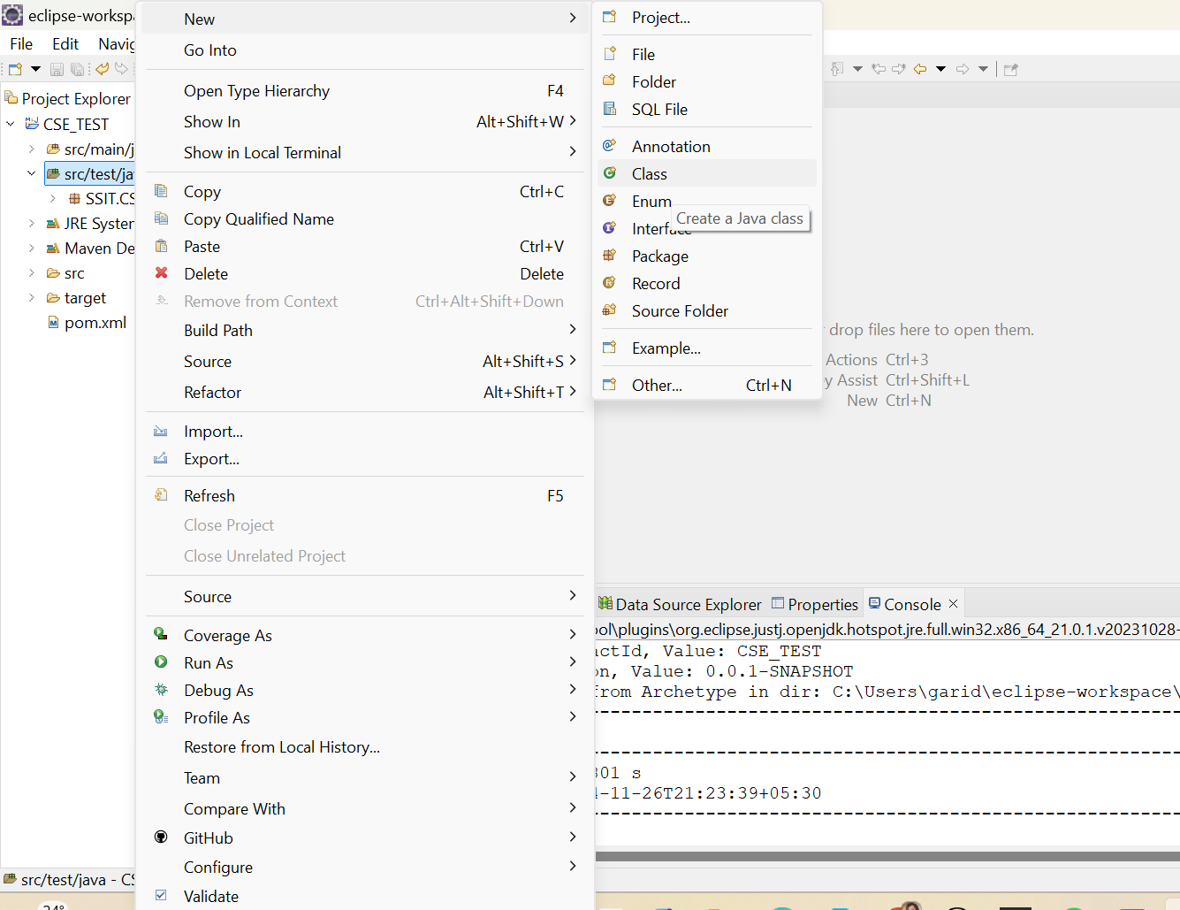4. click on **src/test/java** floder and create a new class and give the class name

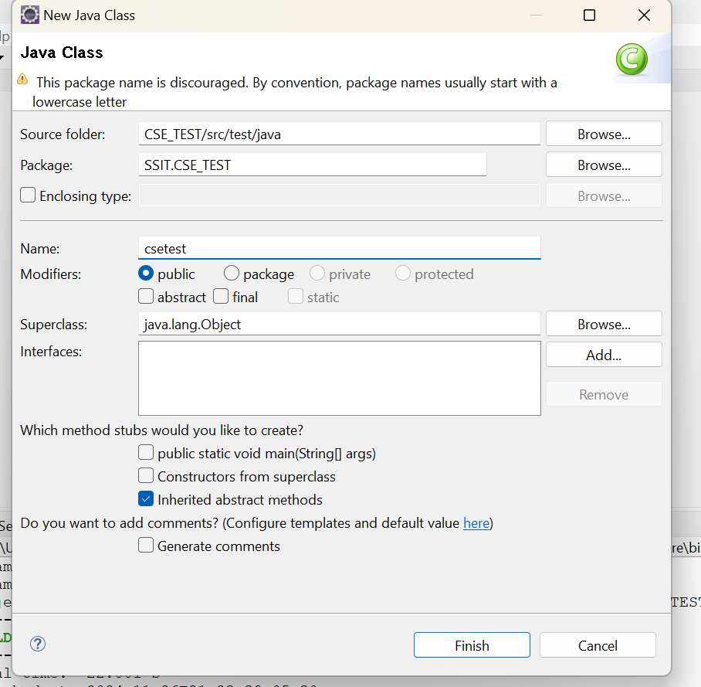

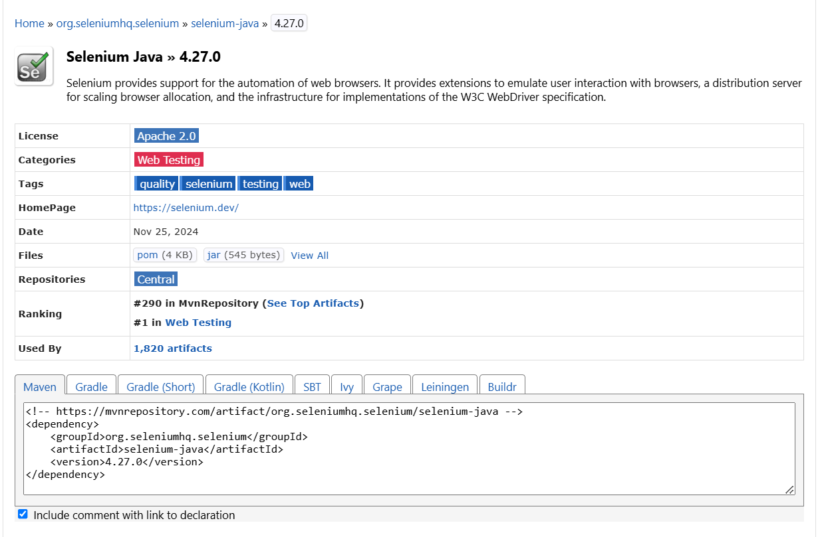5 .Before writing the code add the dependencies at **pom.xml** file those are **selenium and webdrivermanager** for that browse **mvn repositories** in that serch these two and copy past at dependencies

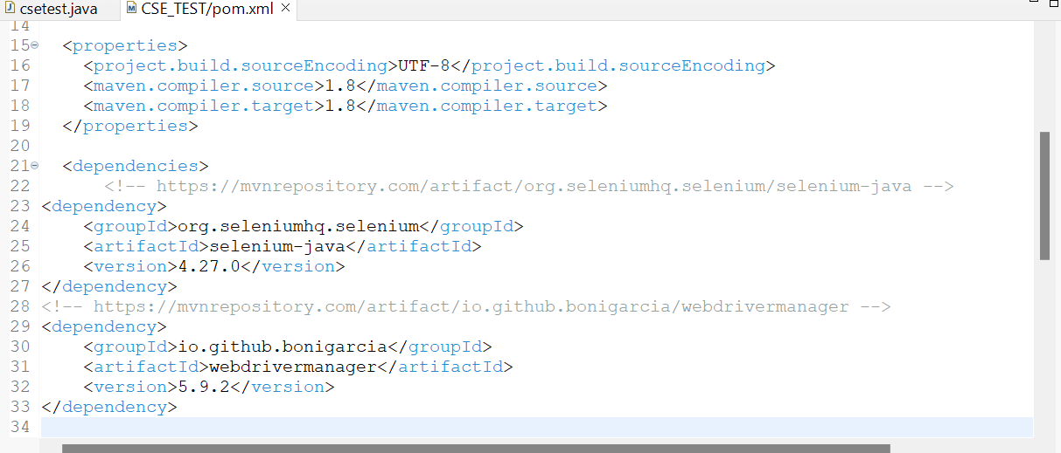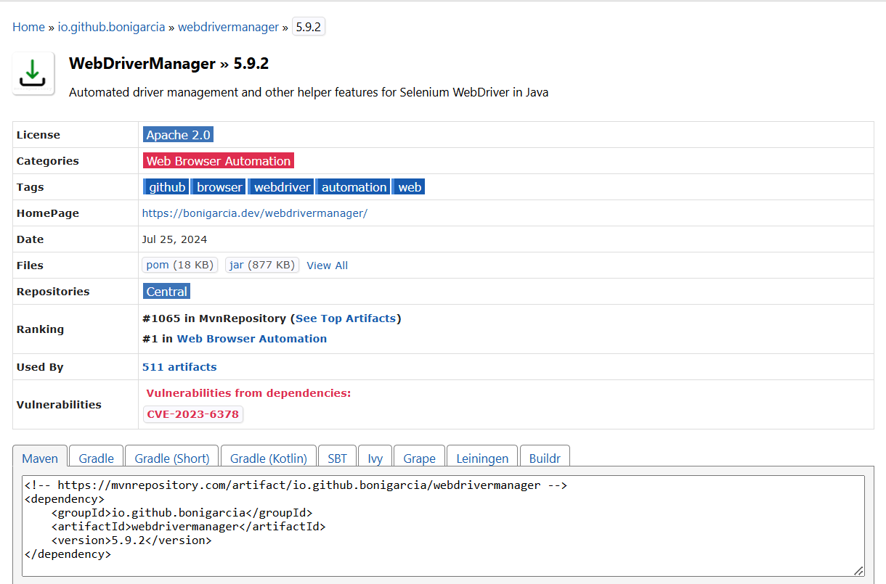

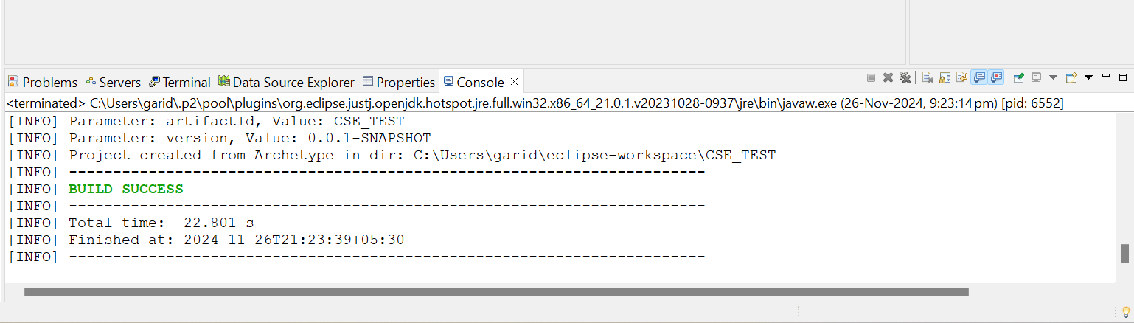

## **simple program to test the saiSpurthi website**

package SSIT.CSE_TEST;

import org.openqa.selenium.WebDriver;

import org.openqa.selenium.chrome.ChromeDriver;

import io.github.bonigarcia.wdm.WebDriverManager;

public class csetest {

public static void main(String[] args) {

// TODO Auto-generated method stub WebDriverManager.*chromedriver*().setup(); WebDriver driver = new ChromeDriver(); driver.get("[http://saispurthi.ac.in](http://saispurthi.ac.in/)");

}

}

**OUTPUT** :

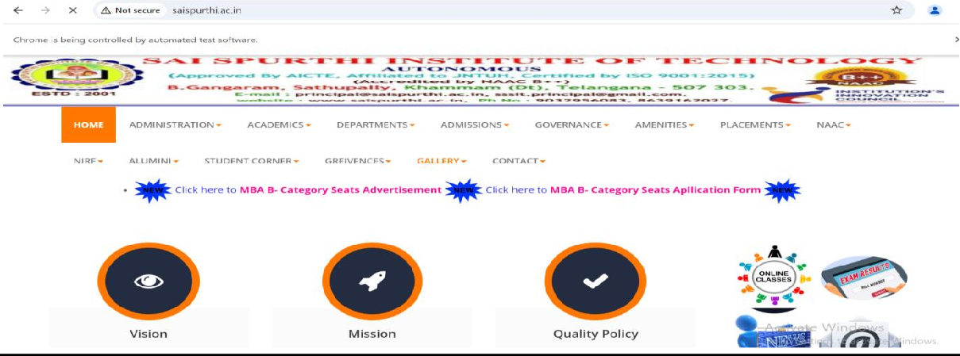

## **program to highlight the boxes that are visible in github**

package SSIT.CSE_TEST;

import org.openqa.selenium.By;

import org.openqa.selenium.JavascriptExecutor;

import org.openqa.selenium.WebDriver;

import org.openqa.selenium.WebElement;

import org.openqa.selenium.chrome.ChromeDriver;

import io.github.bonigarcia.wdm.WebDriverManager;

public class gitcheck {

public static void main(String[] args) throws

InterruptedException{

//TODO Auto-generated method stub

WebDriverManager.*chromedriver*().setup();

WebDriver driver=new ChromeDriver();

driver.get("https://github.com/login");

Thread.*sleep*(3000);

*highlight*(driver,driver.findElement(By.*id*("login_field")));

Thread.*sleep*(3000);

*highlight*(driver,driver.findElement(By.*name*("password")));

Thread.*sleep*(3000);

*highlight*(driver,driver.findElement(By.*className*("headerlogo")));

Thread.*sleep*(3000);

*highlight*(driver,driver.findElement(By.*linkText*("Forgot password?")));

Thread.*sleep*(3000);

*highlight*(driver,driver.findElement(By.*partialLinkText*("Create an")));

Thread.*sleep*(3000);

*highlight*(driver,driver.findElement(By.*tagName*("h1")));

Thread.*sleep*(3000);

*highlight*(driver,driver.findElement(By.*xpath*("//label[contains(text(),'Username or email address')]")));

Thread.*sleep*(3000);

*highlight*(driver,driver.findElement(By.*cssSelector*("input[name='commit']")));

}

public static void highlight(WebDriver driver,WebElement

element) {

JavascriptExecutor jsExecutor=(JavascriptExecutor)

driver;

jsExecutor.executeScript("arguments[0].setAttribute('style','border:2px solid red;background:yellow')",element);

}

**OUTPUT** :

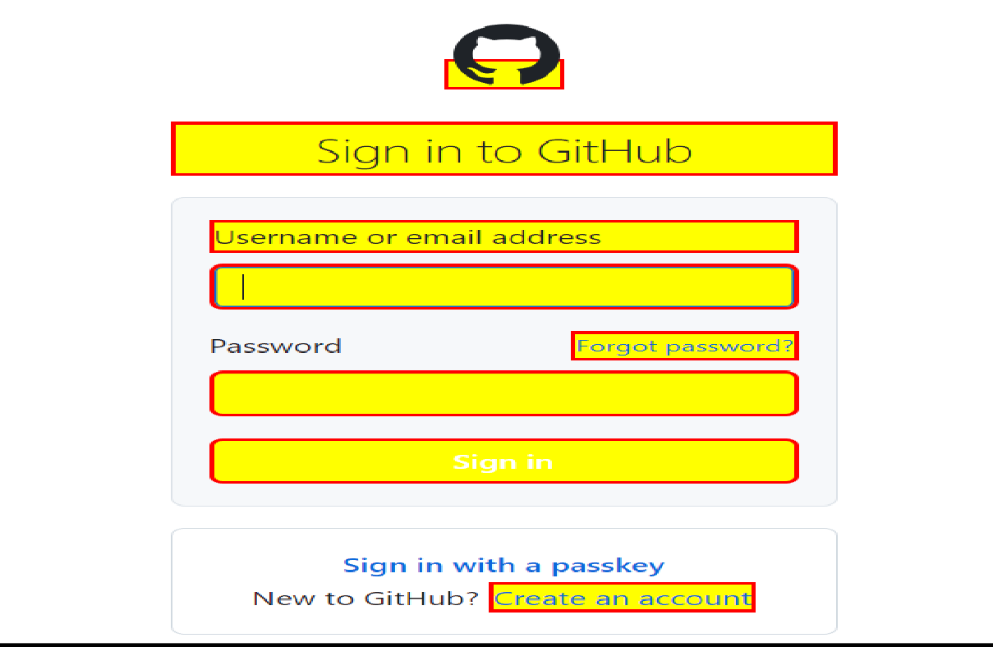

* **Running the html file which is in local disc**

package SSIT.CSE_TEST;

import java.time.Duration; package SSIT.CSE_TEST;

import java.time.Duration;

import java.util.List;

import org.openqa.selenium.By;

import org.openqa.selenium.JavascriptExecutor;

import org.openqa.selenium.WebDriver;

import org.openqa.selenium.WebElement;

import org.openqa.selenium.chrome.ChromeDriver;

import org.openqa.selenium.support.ui.ExpectedConditions;

import org.openqa.selenium.support.ui.Select;

import org.openqa.selenium.support.ui.WebDriverWait;

import io.github.bonigarcia.wdm.WebDriverManager;

public class relogp {

public static void main(String[] args) throws InterruptedException {

WebDriverManager.*chromedriver*().setup();

WebDriver driver = new ChromeDriver();

driver.manage().window().maximize();

driver.get("D:/devopsreg/localreg.html");

// WebDriverWait for max 10 seconds

WebDriverWait wait = new WebDriverWait(driver,

Duration.*ofSeconds*(3000));

// Highlight and fill the First Name

WebElement firstNameField =

wait.until(ExpectedConditions.*visibilityOfElementLocated*(By.*id*("fname")));

*highlight*(driver, firstNameField);

Thread.*sleep*(3000);

// Highlight and fill the Last Name

WebElement lastNameField =

wait.until(ExpectedConditions.*visibilityOfElementLocated*(By.*id*("Lname")));

*highlight*(driver, lastNameField);

Thread.*sleep*(3000);

// Highlight and fill the Date of Birth

WebElement dobField =

wait.until(ExpectedConditions.*visibilityOfElementLocated*(By.*id*("dob"

)));

*highlight*(driver, dobField);

Thread.*sleep*(3000);

// Highlight and fill the Email

WebElement emailField =

wait.until(ExpectedConditions.*visibilityOfElementLocated*(By.*id*("email")));

*highlight*(driver, emailField);

Thread.*sleep*(3000);

// Highlight and select the Gender (Male)

WebElement femaleRadioButton =

wait.until(ExpectedConditions.*visibilityOfElementLocated*(By.*id*("female")));

*highlight*(driver, femaleRadioButton);

femaleRadioButton.click();

Thread.*sleep*(3000);

//Highlight and fill the Phone Number

WebElement phoneField =

wait.until(ExpectedConditions.*visibilityOfElementLocated*(By.*id*("phno")));

*highlight*(driver, phoneField);

Thread.*sleep*(3000);

// Highlight and fill the Address

WebElement addressField =

wait.until(ExpectedConditions.*visibilityOfElementLocated*(By.*id*("addr")));

*highlight*(driver, addressField);

Thread.*sleep*(3000);

// Highlight and click the Checkbox (Accept termsand conditions)

WebElement acceptCheckbox =

wait.until(ExpectedConditions.*visibilityOfElementLocated*(By.*id*("accept")));

*highlight*(driver, acceptCheckbox);

acceptCheckbox.click();

Thread.*sleep*(3000);

// Interact with the Dropdown and highlight it

WebElement calElement =

wait.until(ExpectedConditions.*visibilityOfElementLocated*(By.*id*("opsdropdown")));

*highlight*(driver, calElement);

Select calNameDropdown = new Select(calElement);

// Get and print all options

List<WebElement> calNameDropdownOptions =

calNameDropdown.getOptions();

for (WebElement option : calNameDropdownOptions)

{

System.*out*.println(option.getText());

}

// Select the second option (index 1) andhighlight it

calNameDropdown.selectByIndex(1); // CSM

Thread.*sleep*(3000);

// Highlight and select by value (CSE)

*highlight*(driver,

calNameDropdown.getOptions().get(1)); // Highlight CSE option

calNameDropdown.selectByValue("05");

Thread.*sleep*(3000);

// Highlight and select by visible text (CSM)

*highlight*(driver,

calNameDropdown.getOptions().get(2)); // Highlight CSM option

calNameDropdown.selectByVisibleText("CSM");

Thread.*sleep*(3000);

// Finally, print the selected option text

String selectedText =calNameDropdown.getFirstSelectedOption().getText();

System.*out*.println("Selected option: " +selectedText);

// Highlight and click the submit button

WebElement submitButton =

wait.until(ExpectedConditions.*elementToBeClickable*(By.*id*("submit")));

*highlight*(driver, submitButton);

submitButton.click();

Thread.*sleep*(3000);

// Close the browser

driver.quit();

}

// Highlight function that changes the element's style to make it visually stand out

public static void highlight(WebDriver driver,

WebElement element) {

JavascriptExecutor jsExecutor =

(JavascriptExecutor) driver;

jsExecutor.executeScript("arguments[0].setAttribute('style','border: 2px solid red; background: yellow;')", element);

}

}

**OUTPUT** :

